The Application of Statistical Financial Method

**Group Member: Xueyuan Fan (xf2202)**

**Zhikang Dong (zd2241)**

**Wenjun Yang (wy2347)**

**Yue Zheng (yz3710)**

**Tao Huang (th2823)**

**Chui Kong(ck2964)**

1. **Summary**

We want to collect data from 15 asset and make a portfolio. The idea is that we want to investigate the covid-19 effect to our portfolio by applying several statistical methods that we learned in the lecture.

1. **Data Analysis**

**2.1 Data Source**

We choose 15 assets from different industries to make our portfolio, which can make a diversification effect. And we uses S&P 500 as the benchmark to see how well our chosen assets performed compared to the market.

The 15 equities are: (from 12/01/2015 I to 04/01/2020, daily frequency)

3M(MMM), American Express(AXP), Apple. Inc(AAPL)，Boeing(BA), Caterpillar Inc(CAT), Chevron Corporation(CVX), Cisco Systems(CSCO), The coca-cola Company(KO), Johnson & Johnson(JNJ), Nike(NKE), Procter&Gamble(PG), Raytheon Technologies(RTX), UnitedHealth Group(UNH), Verizon(VZ), The Walt Disney Company(DIS)

**2.2 Sample Data Statistics**

Table 2.1(appendix) shows the means and standard deviation of 15 equities. Boeing has the largest variation during selected time, and Coca-cola Company varies the least among these 15 equities. It is not difficult to understand: Boeing is affected by several accidents due to safety problems and also influenced more by covid-19 depression. However, Coca-cola Company depends on consumer goods which is affected less by the covid-19.

We also calculate the mean, standard deviation, skewness, kurtosis coefficient and beta of returns of each equity. The result is in table 2.2. Apple has the largest mean of returns, and The Walt Disney Company had the lowest return. As for the standard deviation, Coca-cola Company has the lowest one and the return of Boeing has the largest variation. Beta can be regarded as a measure of volatility compared to the market.

The result is same as what we get from the standard deviation: Boeing has the largest beta, which means its volatility is significantly large compared to the market. Since we use beta of SP500 as the benchmark(S&P500 beta is 1.00 ), we can see that half of these equities are more risky than the market.

**2.3 Graph Information**

From Chart 2.3, it suggests that stock prices of most of the companies generally have an upward trending. And even some fluctuation of stock prices from the chart can be explained by facts. For instance, the most obvious phenomena is that during the recent covid-19, all of the stock prices of those 15 companies decrease significantly. Furthermore, the stock prices of some companies like CVX, Coca-cola, Nike and Boeing has returned to the original price level of 2015.

From the chart 2.4, we can see that Apple and Boeing have huge volatility compared to the market(S&P 500). Boeing, as we said above, is significantly affected by safety problems of 737 MAX. The reason why Apple’s return varies a lot in the end of 2018 is that the financial report of the forth quarter shows that the sales of iPhone had been growing slowly as the analysts decreased their expectation. Also, the growing concern of Iphone as a too large proportion of revenues makes investors throw their shares.

2.4 Sharpe Ratio

In Table 2.5, we sort the order of Sharpe ration from low to high one. Unitedhealth Group has the highest Sharpe ratio, meaning that it can provide the highest return under normalized risk. Notice that DIS, CVX and 3M have negative Sharpe ratio, which is reasonable. This is because that their average return is lower the market return.

1. **Portfolio Theory**

In this section, we are describing the performance of 15 assets in a portfolio, includes minimum variance portfolio (MVP), tangency portfolio & sharpe ratio, and the effect of adding short sell.

**3.1 Portfolio with no Short Sell**

In table 3.1, we restrict selling short and obtain the MVP daily average return (0.000193) and its standard

deviation (0.00969). The daily MVP return is higher than the daily risk-free rate (0.00004). If we convert them into yearly base, the MVP has its return equals 6.96% and risk 18.38%. The return is higher than the yearly risk-free rate (1.54%) by 5.42%.

The point T has the highest Sharpe ratio is called the tangency portfolio. The daily tangency return is 0.0008 and its standard deviation is 0.01441. The daily return is higher than the daily risk-free rate. If we convert them to yearly base, the tangency return will be 29.32% and the risk will be 27.34%. The return is higher than yearly risk-free rate (1.54%) by 27.78%.

In table 3.2, The tangent portfolio gives more weight to UNH and AAPL. (They have the higher Sharpe Satios, shown in Table 3.3).

In table 3.4, the MVP gives more weight to the VG, KO, JNJ (They have lower standard deviations, shown in Table 3.5).

It demonstrates that MVP tends to select the assets with minimal risks disregarding the return and tangency portfolio tends to select assets with high Sharpe Ratio.

The Efficient Portfolio Frontier is presented in Figure 3.1, The blue line is the sharp slope of tangency portfolio. The red line represents the efficient frontier. The star mark at the lower end of the blue line is the risk-free rate (daily risk=0, daily return=0.00004). The star mark at the upper part of the blue line is the tangency portfolio (daily risk=0.008, daily return=0.014). The cross mark at the lower end of red line is MVP (daily risk=0.00019, daily return=0.0097) .

**3.2 Portfolio with Short Sell**

In table 3.6, we allow selling short and obtain the MVP daily average return (0.000179) and its standard

deviation (0.00952). The daily MVP return is higher than the daily risk-free rate (0.00004). If we convert them into yearly base, the MVP has its return equals 6.4% and risk 18.1%. The return is higher than the yearly risk-free rate (1.54%) by 3.86%.

The daily tangency return is 0.0061 and its standard deviation is 0.0636. The daily return is higher than the daily risk-free rate. If we convert them to yearly base, the tangency return will be 220.77% and the risk will be 120.74%. The return is higher than yearly risk-free rate (1.54%) by 219.23%.

In table 3.7 and table 3.8, The tangent portfolio gives more weight to UNH and AAPL, while the MVP gives more weight to the KO, VG, JNJ. Which are similar to the tangent portfolio and MVP without considering short sell. The permission of short sell leads to the decrease of risk limitation, and the decrease of risk limitation leads to the increase of expected return.

The Efficient Portfolio Frontier is presented in Figure 3.2. The blue line is the sharp slope of tangency portfolio. The cross mark at the lower end of red line is MVP.

1. **Time Series Analysis**

In this section, we would like to analyze performance of stocks and forecast stock price based on time series theory, especially GARCH models.

**4.1 Time-varying Betas**

CAPM (capital asset pricing model) is one of the most common financial model. People use this model to establish the portfolio and estimate returns and market sensitivity. Here, we can use GARCH model to find betas (stock sensitivity) of the stock in different time.

We have the CAPM model like this:

where (Jensen index) means the mispricing of the stock compared with the market.

Generally, if is significantly greater than 0, which means that the stock responds aggressively to the market. On the other hand, if is relatively close to 0, then the market doesn't have much impact on it. Thus is regarded as less risky than the market, and indicates a high risk investment.

In practice, we would like to see an asset outperform the market with less risk. Mathematically, and is small.

For the CAPM model above, we have:

where and are the log-return of the stock and the index we choose at time

By fitting a good GARCH(1, 1) model, we can easily get volatility of the stock and the market.

Here we can use:

The result plots are in the appendix (Figure 4.1).

By selecting positive and five smallest expected , we have these five stocks: PG, KO, VZ, JNJ, DIS. (Ordered by descending )

The industries these stocks belong to respectively are Fast moving consumer goods, food industry, Telecommunication, Pharmaceutical industry, Broadcasting and entertainment. It seems like traditional industries and essential industries are less risky to the market.

**4.2 Minimum Variance Portfolios**

In Markovitz portfolio theory, we can derive minimum variance porfolios from the time series. Combined with GARCH model, we can estimate time-varying covariances of asset returns for portfolio selection. Here we assume that short selling is not allowed. Then we solve this quadratic optimization problem:

For simplicity, we use five stocks we mentioned before to establish a portfolio. Here we estimate covariances by using GARCH(1, 1) model for individual asset returns and their sums and differences.

Here, we plot time-varying portfolios and time-varying risks below.

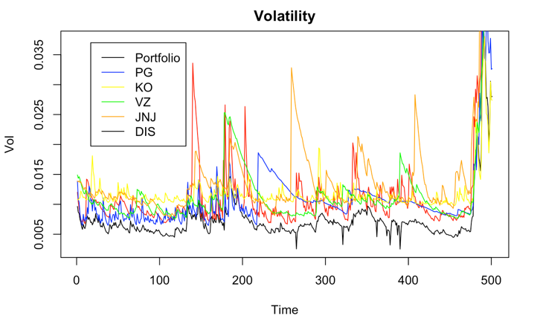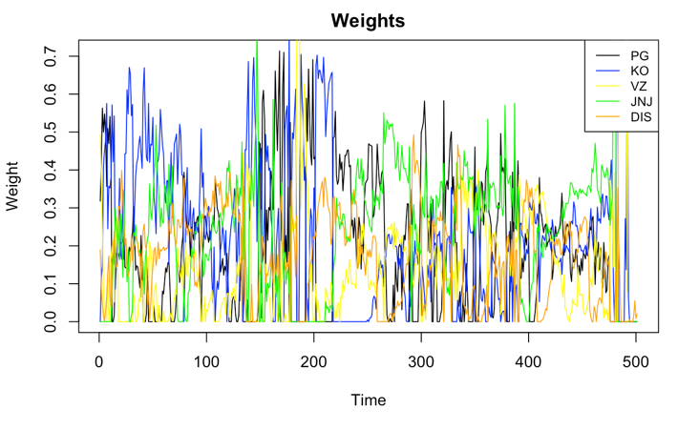

As expected, the minimum variance portfolio reduces the risk.

**4.3 Forecasting**

Another application of GARCH model is to improve the modeling and forecasting of a time series. From the price plot, we can see a clear trend, which means the time series is non-stationary. Therefore, a pure ARMA model for price change is not adequate. In order to analyzing volatility, we can use ARMA-GARCH model to handle complexity of data and improve prediction. Again, we use PG, KO, VZ, JNJ, DIS as examples.

Firstly, we plot price and price changes data of each stock (Figure 4.2). We can find weak stationarity in price change plots. Therefore, we use price change data instead of raw price data.

Next, we use the function auto.arima to find best ARMA coefficients and combine it with GARCH(1, 1) model.

Finally, we would like to use skew t-distribution innovations instead of normal innovations to fit the data.

And here is one-step ahead prediction and two-steps ahead prediction results.

One-step ahead prediction

|  |  |  |  |
| --- | --- | --- | --- |
| Stock | meanForecast | meanError | SD |
| PG | 0.2516707 | 5.543471 | 5.543471 |
| KO | 0.0136311665 | 1.969738 | 1.969738 |
| VZ | 0.0195942697 | 1.366333 | 1.366333 |
| JNJ | -0.0015551330 | 5.977686 | 5.977686 |
| DIS | 0.18674672 | 6.379339 | 6.379339 |

Two-steps ahead prediction

|  |  |  |  |
| --- | --- | --- | --- |
| Stock | meanForecast | meanError | SD |
| PG | 0.0000000 | 5.543774 | 5.535937 |
| KO | -0.0002477449 | 1.945809 | 1.945480 |
| VZ | -0.0003691687 | 1.310983 | 1.310730 |
| JNJ | -0.0003091272 | 5.927048 | 5.926557 |
| DIS | 0.03016133 | 6.401113 | 6.387171 |

We can know that ARMA-GARCH model yields good one-step ahead and two-steps ahead predictions.

1. **Universal Portfolio**

**5.1 Background Information and Basic Definition**

For academic purpose, ﬁrst we assume that there is no transaction cost and each share is divisible.

In this section, we’ve tried the 4 following universal portfolio strategies:

1. **Preliminary Portfolio:** A portfolio consisting of 15 stocks with equal total value, and no adjustments are made during the whole time.
2. **Naïve CRP:** Adjust the shares we hold on each stock according to the change in their value and ensure the allocation proportion of different stocks remain the same (in this case, it would be 1/15).
3. **BCRP:** BCRP is to maximize the portfolio wealth at time n over all CRP, based on history price and present price (unknown), which makes it unachieved in real life, but it can serve as a benchmark.
4. **SCRP:** SCRP is a strategy similar to BCRP, but only relies on historical data, making it achievable in real life. Each adjustment is the best allocation we can have based on previous data.

**5.2 Comparison between Strategies**

This section is aimed at comparing the performance of 4 strategies, through which we can gain a more intuitive understanding about the nature of strategies and explore the underlying pattern of market in this period.

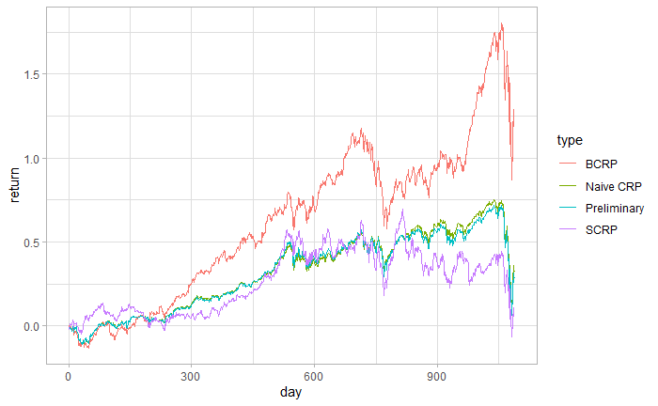

|  |  |
| --- | --- |
| **Method** | **Overall Return** |
| **Preliminary** | 28% |
| **Naïve CRP** | 32% |
| **BCRP** | 125% |
| **SCRP** | 8.5% |

* Naïve CRP is doing good job compared with others. Based on the nature of CRP, we can see it tends to buy in stocks whose value is decreasing. This strategy will perform well if the drop in price is temporary, because we generally buy stocks at low price and sell them at high. The fact that it’s doing good suggests that stocks during this period are very volatile and don’t not have much momentum.
* We can see from the graph that preliminary portfolio and naive CRP are very close. The reason behind that could be the return in each stock is relatively close, because those mega-companies are stable and rarely have any big ﬂuctuation in their stock price. Hence whether keeping the proportion still or not, the general return will be similar.
* SCRP only gives us 8.5% return. In fact, if we take transaction cost into consideration, the result would be much worse. By its nature SCRP would adjust present strategy using every historical data, if the stocks have good momentum, that is to say they tend to follow their previous trend, then this strategy would be the most successful. Consequently, its terrible performance suggests there isn’t much momentum in the stocks, which matches our insight from Naïve SCRP.

**5.3 More into COVID-19 Period**

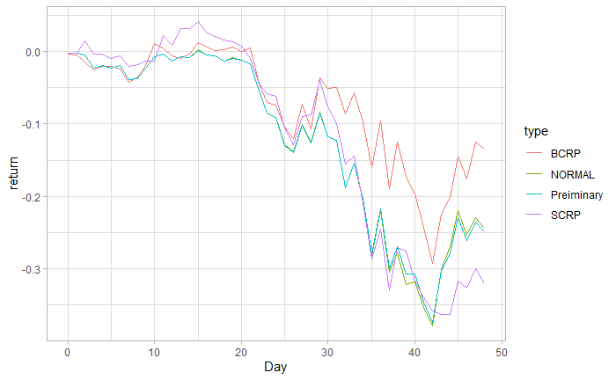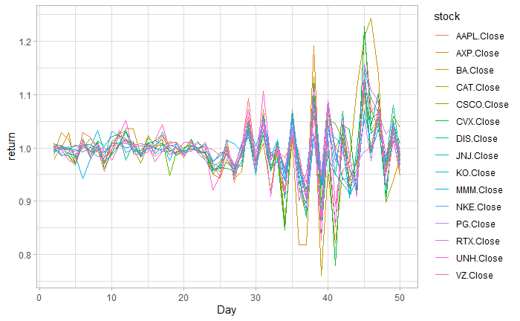

This section focuses solely on the pre-outbreak and outbreak period of COVID-19. Again, we perform the four strategies on this period, and compare their performance.

|  |  |  |  |  |
| --- | --- | --- | --- | --- |
| **Method** | **Preliminary** | **Naïve CRP** | **BCRP** | **SCRP** |
| **Overall Return** | -25% | -24% | -14% | -32% |

All these strategies can’t save investors from losing money during recent market meltdowns, not even the unachievable BCRP. The better way to invest money and keep risk under control under this circumstance would probably be shorting futures and options on stock markets.

1. **Risk Management**

For this part, we assume that we have $100,000 to invest. For each asset, we estimated the 5% value-at-risk and expected shortfall on $100,000 investment over a one-month investment horizon based on the normal distribution and used the estimated means and variances of the selected assets.

We also did the same things using the other method which is nonparametric method to investigate which assets have the highest and lowest VaR at a one-month horizon? And which assets have the highest and lowest expected shortfall for a month? we also used the bootstrap to compute estimated standard errors and 95% confidence intervals for our 5% VaR and expected short fall.

From the table 5.1 and 5.2, we can observe that two estimations give different results.

The Normal methods turns out BA has maximum VaR (3964.577) and maximum expected shortfall (4979.595), KO has minimum VaR (1898.815) and minimum expected shortfall (2383.649). The Nonparametric method turns out CAT has maximum VaR (2938.054) and maximum expected shortfall (5756.574), KO has minimum VaR (1502.872) and minimum expected shortfall (2815.664). However, there are some disparities. It happens because not all assets are following the normal distribution.

Based on the results given above, we can learn that Boeing company has maximum VaR from both of two estimations because this company belongs to Aerospace Defense industry which is sensitive to systematic risks. So, the rising geopolitical uncertainty and outbreak of coronavirus have further increased the volatility of airplane’s stocks that have already plunged over the past month. As the major US aerospace company, Boeing company’s revenues are closely tied to the macroeconomics. With a beta larger than one, Boeing company is riskier than the over the market. Therefore, when the uncertainty in the market spikes, we can expect a higher swing than the market.

1. **Copula**

We compared 5 kinds of copulas: Normal copula, T copula, Clayton copula, Gumbel copula, and Frank copula.

|  |  |  |  |  |  |
| --- | --- | --- | --- | --- | --- |
| Copula | Normal | T | Clayton | Gumbel | Archm |
| AIC | -10885.14 | -11596.8 | -7716.238 | -7676.398 | -8091.597 |
| BIC | -10880.15 | -11686.83 | -7711.244 | -7671.404 | -8086.603 |
| Likelihood | 5443.572 | 5800.411 | 3859.119 | 3839.199 | 4046.798 |

Observations:

* T copula has the lowest AIC and BIC value which means that T copula fits better.
* Also, T have the max Likelihood which shows that T copula fits the model better.
* Our data shows a slightly heavy tail correlation.
* T copula fits the best compared with other copulas. It is good for modeling data since the t-copula emphasizes extreme results

**VIII. Conclusion**

1. The stock market between 2015-12-01 and 2020-04-01 lacks momentum, meaning the stocks tend to fluctuate instead of rising or falling for a few days in a row.
2. The drop in stocks price during COVID-19 is a universal trend, no universal portfolio discussed can help investors from losing money.
3. The outbreak of COVID-19 has further increased the volatility of airplane’s stocks and makes Boeing company become the riskiest company of the profile.
4. The code was uploaded at https://github.com/Dongzhikang/GR5261-Final-Project

APPENDIX

Section 2:

Table 2.1 Table2.2

**

**

Table2.5



Table 3.1

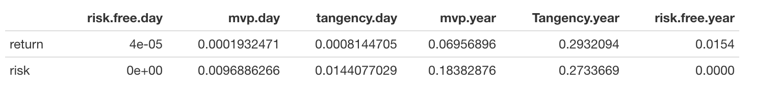

Table 3.2

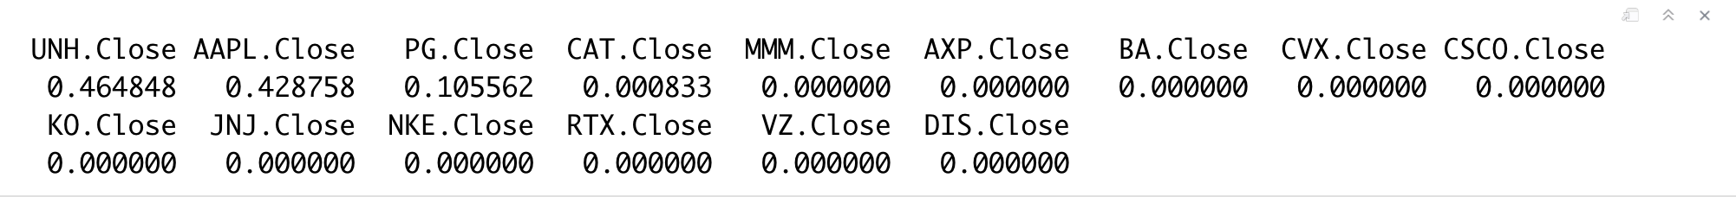

Table 3.3

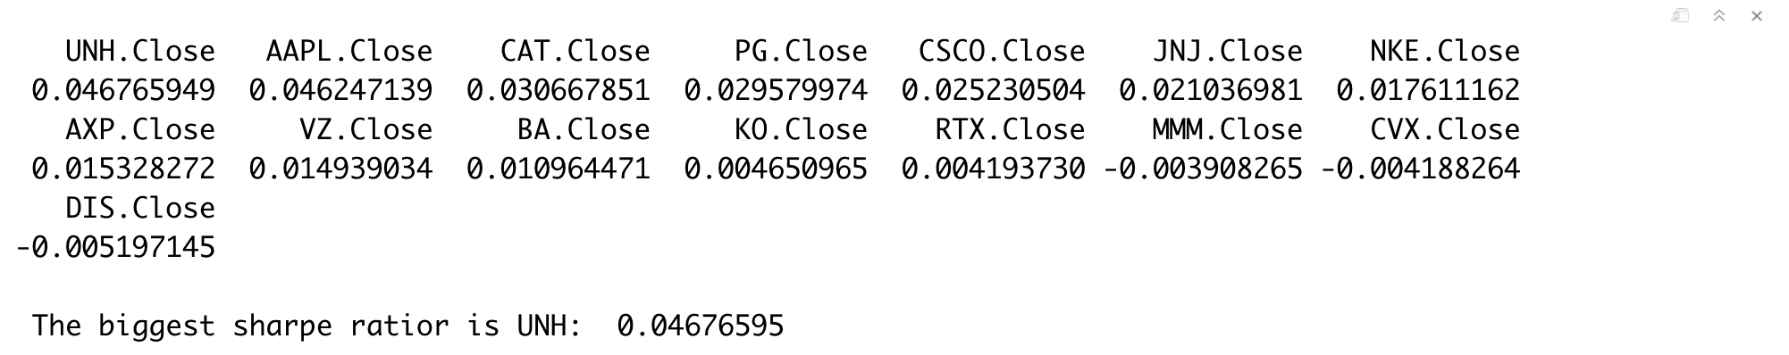

Table 3.4

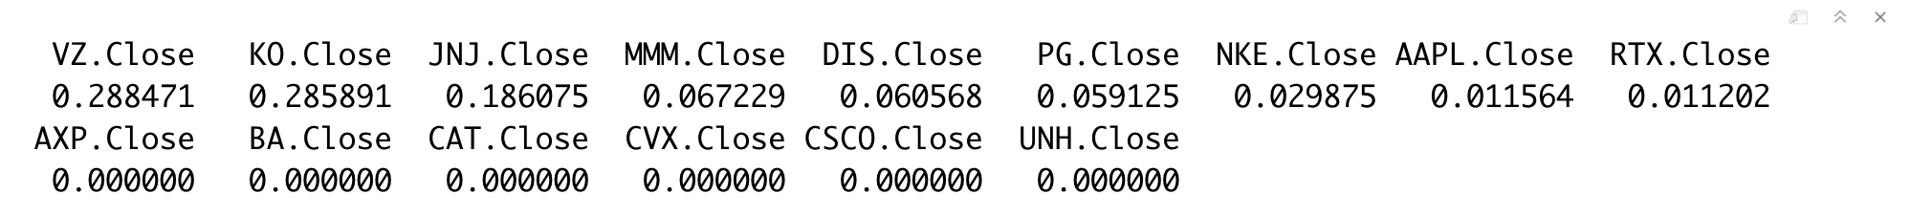

Table 3.5

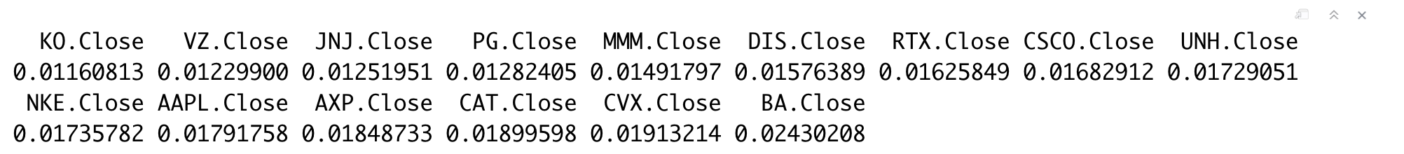

Table 3.6

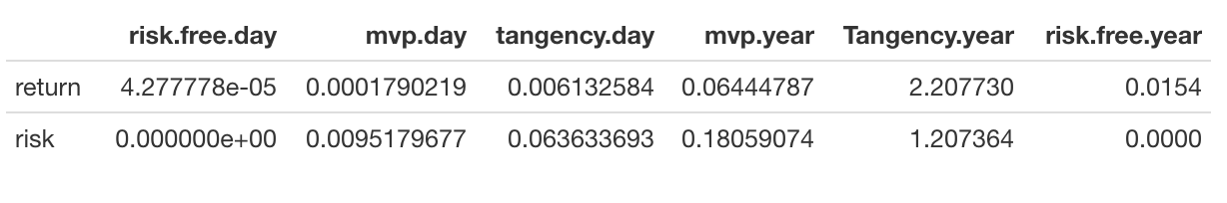

Table 3.7

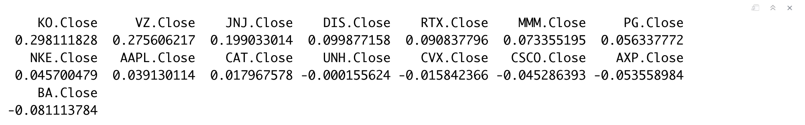

Table 3.8

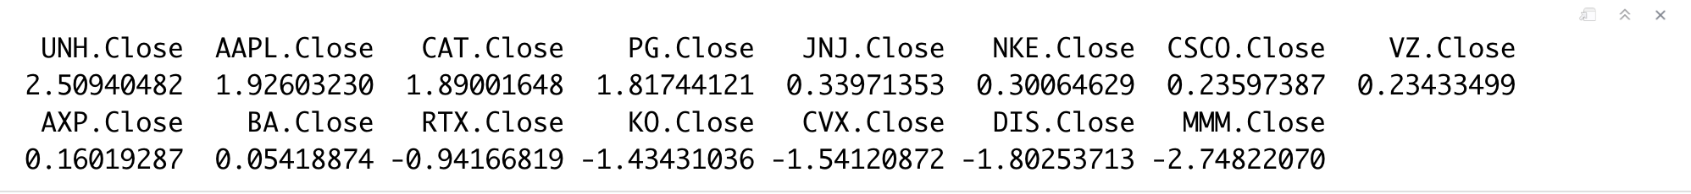

Figure 3.1

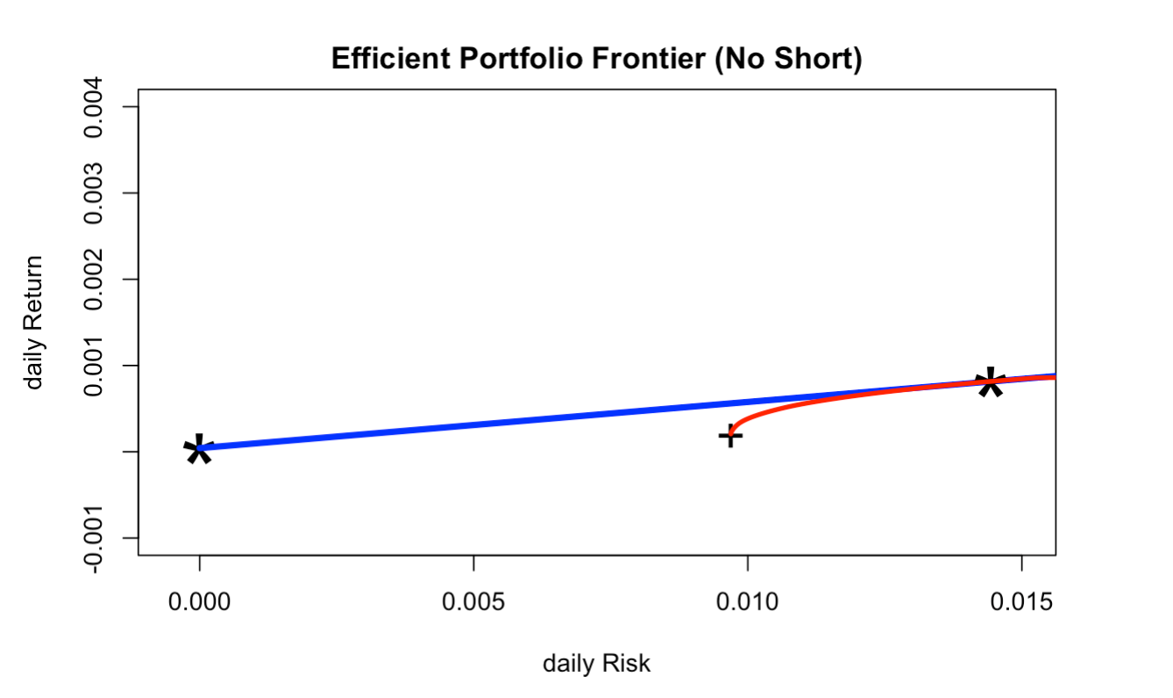

Figure 3.2

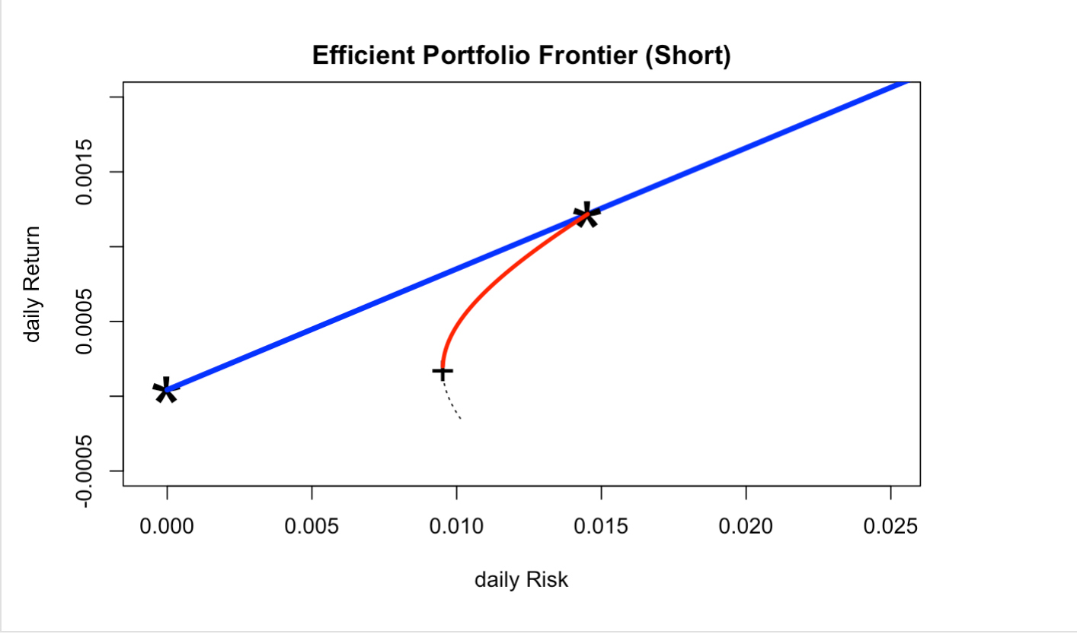

Figure 4.1

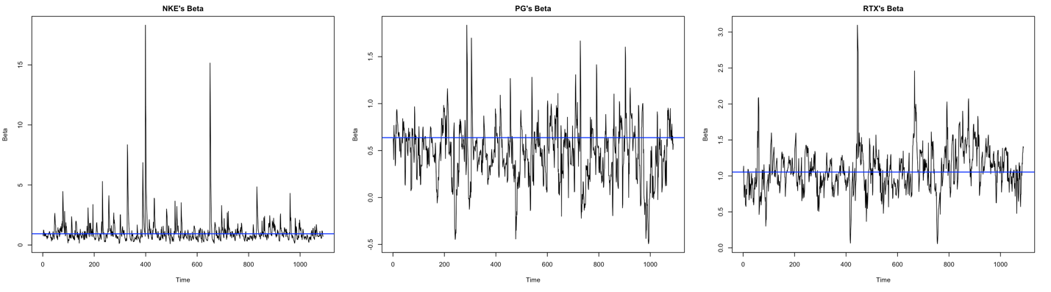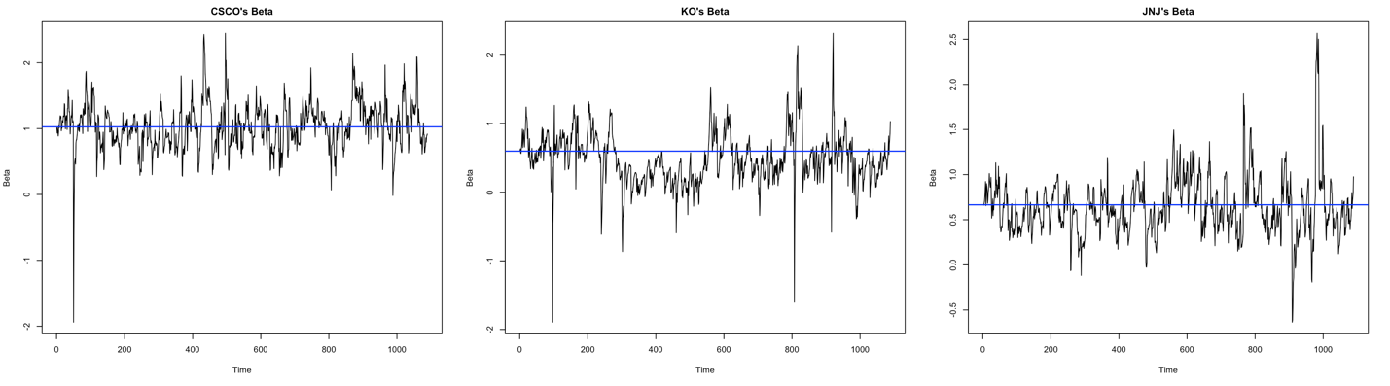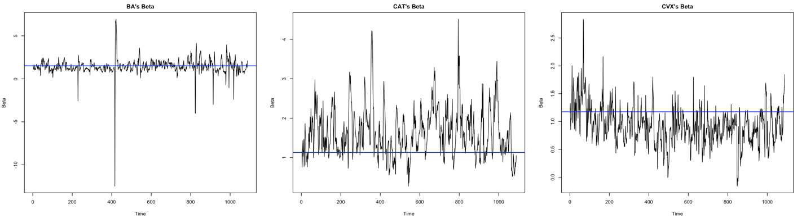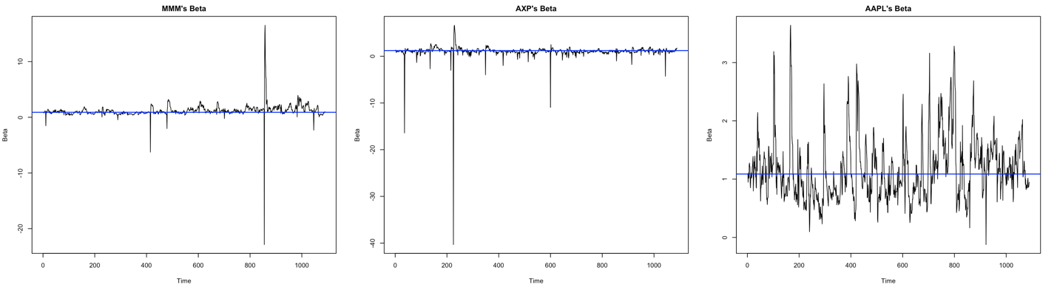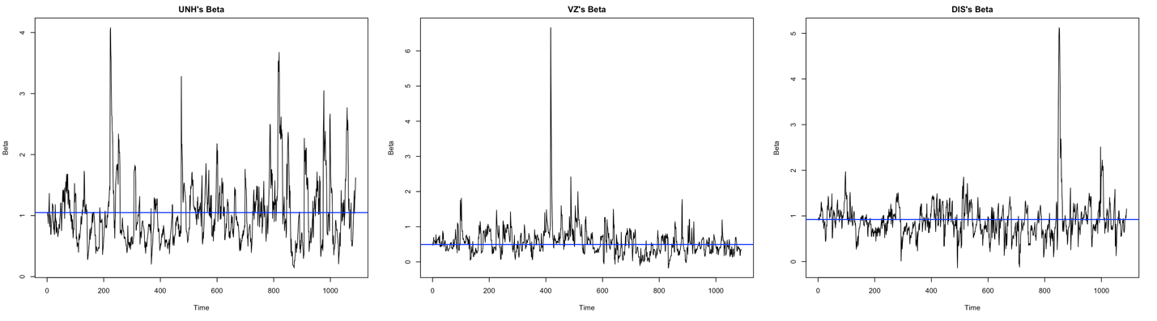

Figure 4.2

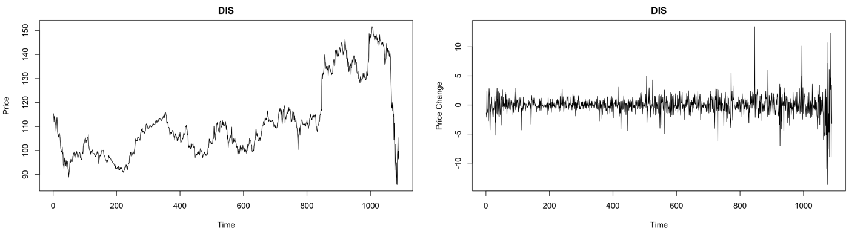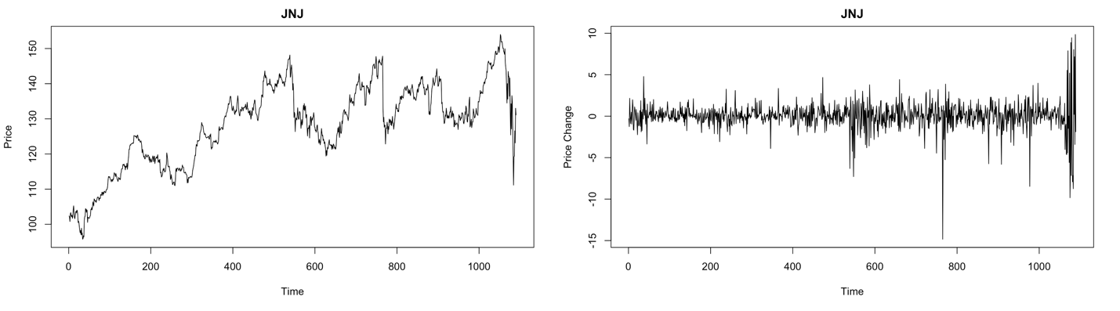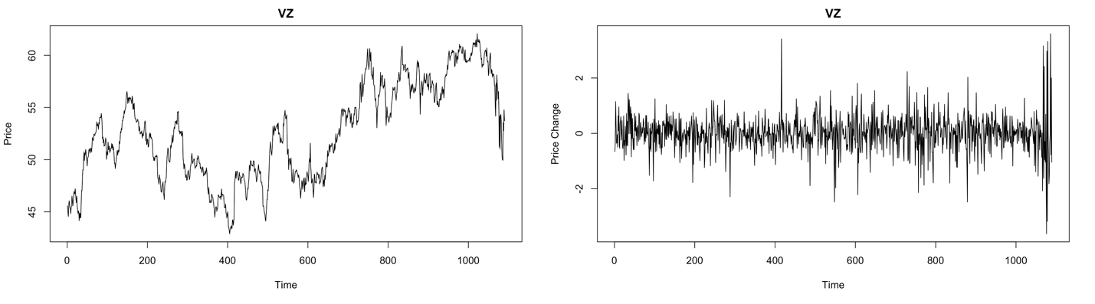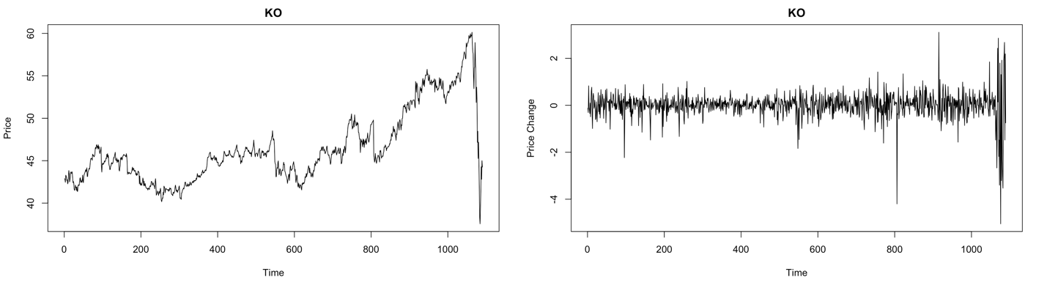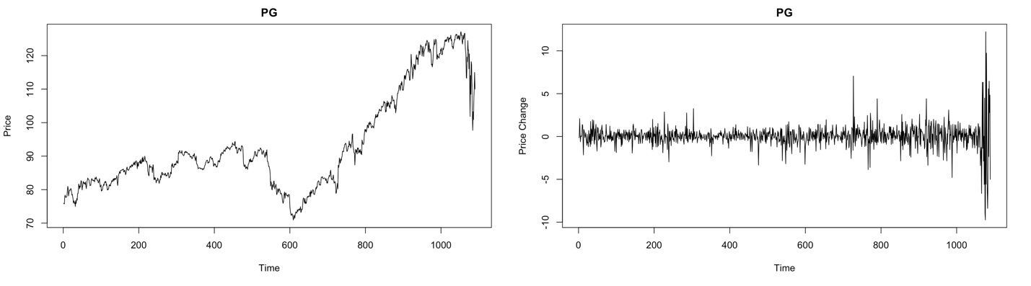

Table 5.1

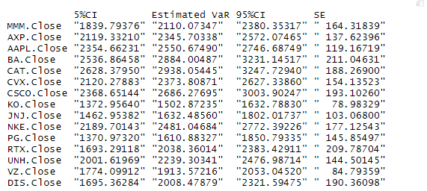

Table 5.2

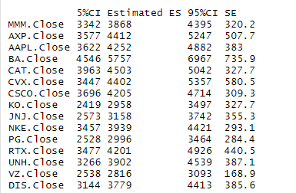

GitHub link: https://github.com/Dongzhikang/GR5261-Final-Project